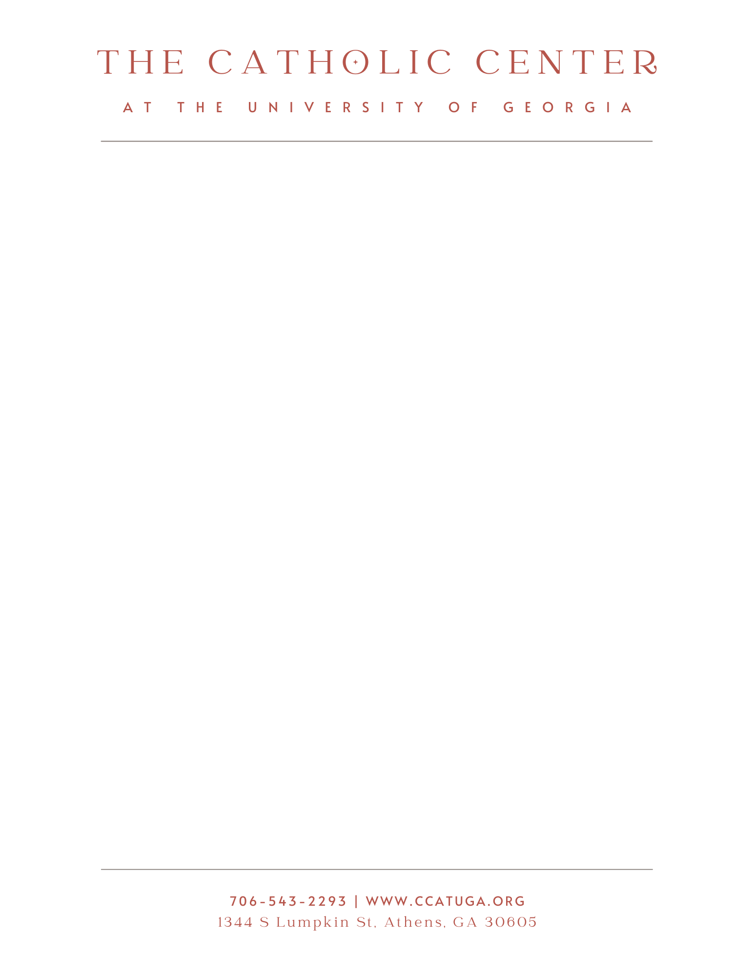

**Promotions & Special Projects**

**Hours:** 12 – 20 hours per week between August 2024 and May 2025. Includes training. Scheduling is flexible.

***Responsibilities:***

* Edit and Publish Weekly Bulletin
  + Print & Post to Facebook
  + Publish on Website
  + Send out via MailChimp
* Creation of Promotional Materials
  + Golf Tournament Brochures, Center Signage, Fliers, etc.
* Assist with Marketing & Development
  + General Design Work
  + Serve on development team, focused on communication and fundrasing
  + Brainstorm, Plan and Execute Communications/Development Plans
* Parish Emails
  + Send via Mailchimp
  + Includes Bulletin, Announcements, etc.
* Facebook
  + Post Bulletin
  + Post Pictures from Special Events
  + Post General Updates
* Website Upkeep
  + Update Online Forms, Announcements, Special Events, etc.
* Office Work and Miscellaneous Tasks as Needed
  + Print, Copy, Move Furniture, etc.
  + Set up for Events
  + General Receptionist Duties
* Serve on Golf Committee for the Annual Catholic Center Dooley Classic
  + Manage sponsor and registration information
  + Attend and take notes during monthly committee meetings
* Data
  + Data entry & analysis
  + Manage spreadsheets

***Qualifications:***

* Skilled in Verbal and Written Communication
* Knowledgeable in Microsoft Office - Publisher, Excel, Word
* Experience in Canva and/or Adobe Creative Cloud
* Creative, Eye for Design
* Strong Organizational Skills
* Strong Customer Service Skills
* Willingness to Learn New Platforms and Skills
* Students in Management Information Systems, Public Relations, Advertising, Marketing, Communications or Related Program Preferred

Application:

* If interested, please send your resume to Paige Clarke at bulletin@ccatuga.org. The application deadline is August 1st.